Supplementary Table 1. Aegilops molecular markers.
Markers are designed for use in KASP assays except for 4G which was a COS marker used previously (Howard et al., 2011).
Aegilops marker | Primer (VIC) | Primer (FAM) | Primer common | Wheat 4BS Ortholog
 | VIC tag = GAAGGTCGGAGTCAACGGATT | FAM tag = GAAGGTGACCAAGTTCATGCT
TC60 | TCGTCGCCATGGAGGAGg | TCGTCGCCATGGAGGAGa | AGGACCAAAGACCGGGCG | TraesCS4B01G025500
TC61 | ACAGTCTCCTAGGCGTCTGc | ACAGTCTCCTAGGCGTCTGa | CTACCAGCAGGAGAATAGGATC | TraesCS4B01G025600
TC58 | AGTTGATACAGGTGCAGtTTa | AGTTGATACAGGTGCAGgTTc | CCATCTATTTGGCGGCAA | TraesCS4B01G026000
KT108 | GGGAGATTGTGGTTATCTGGAAc | GGGAGATTGTGGTTATCTGGAAt | CAGCTGACTTCAATTCATTTAGC | TraesCS4B01G027900
KT116 | GGAGATTGTGGTTATCTGGAAc | GGAGATTGTGGTTATCTGGAAt | CTGACTTCAATTCATTTAGCACTG | TraesCS4B01G027900
KT113 | TCCGAgGTTCCAGAGCACGg | TCCGAgGTTCCAGAGCACGa | TGCTGTCAAGATGATTGTATGGAG | TraesCS4B01G028900
TC36 | GCAGACTCAAACAACTTGCTc | GCAGACTCAAACAGCTTGCTt | CAGCTTTCTGAACTTGAGAGG | TraesCS4B01G029300
TC35 | ATGTTGCCGTTGTAGTGGAc | ATGTTGCCGTTGTAGTGGAt | AGCACGCGGAGATCGACA | TraesCS4B01G029400
KT117 | CTTCAAATAAATGGGGGCAc | CTTCAAATAAATGGGGGCAa | CCCAGTGGATGAGAATTTTC | TraesCS4B01G031000
TC73 | GGATGGAACAATCAGAAAGc | GGATGGAACAATCAGAAGGa | ACCGGGATACAACCTCAGG | TraesCS4B01G029700
KT70 | GCATGTCTTTAAGATATACATAAATaaatAAAC | GCATGTCTTTAAGATATACATAAATAAAC | AAGTAAGATGCCTTTCTGAAGTTCT | TraesCS4B01G030400
KT110 | ATTTGGCATGCGGAATGGCTc | ATTTGGCATGCGGAATGGCTa | TTCATTCATACTTGATAATGCCC | TraesCS4B01G030500
TC30 | GAAATCATTCGCCCCTGAc | GAAATCATTCGCCCCTGAa | GAGCTGCAGATTTGTTCCTG | TraesCS4B01G031300
KT121 | TAGGCCCAGCACTGGTCAAc | TAGGCCCAGCACTGGTCAAa | TTACCTGAGATGTTTGATGACA | TraesCS4B01G032400
TC34 | CAAGTACGGCCTCCCgAa | CAAGTACGGCCTCCCcAg | GGTGTAGGAGCTGACCGAG | TraesCS4B01G037000
TC28 | GCCTTGCGCGCGAGgACc | GCCTTGCGCGCGAGcACg | AAGAACTCGGAGAAGCG | TraesCS4B01G033900
TC26 | CTGGTGTACtATGGTCTGATCg | CTGGTGTACgATGGTCTGATCa | TAGCTTGTGTGGTTCATGTTAAT | TraesCS4B01G035600
TC33 | GCATTTGAGGTGgAGGTCTg | GCATTTGAGGTGaAGGTCTa | CCAGAGAAGCAAGTGACCG | TraesCS4B01G037000
4G | GCAATCACGAACGGCTCGATCA | ATCTGGCAGCTTGCCAAGGCT | - | TraesCS4B01G037800

Supplementary Table 2. PCR primers for cloning and analysis of FLO6 genes.
A. Cloning primers.
The DNA polymerase used was Phusion HF (international.neb.com) and the PCR conditions were: (98 ºC for 30 s), 35 cycles (98 ºC for 10 s, 60 ºC for 30 s, 72 ºC for 15 s), (72 ºC for 10 min), 10 ºC hold. The clones were sequenced using the cloning primers and with additional internal primers (not shown).

Forward primer | Sequence (5’-3’) |  | Reverse primer | Sequence (5’-3’)
KT106 KT Mf |  | CAGCAAGAATCAAGC | KT106 KT Mr | GCAGGATTGGGCCATACAAC
KT106 KT Ff |  | GCAGATGTGGTAAACGGGTT | KT106 KT Gr | TCCCATGGTTGTTCACGGTA
KT106 KT Hf |  | GCTCTGTGTTTGCCTGCTTA | KT106 KT Vr | CTTCTGCCGACCGATAGCTA
KT106 KT Wf |  | GAACAATCAGAAAGCGGCATTT | KT106 KT Wr | ACTAACCACGGACAACTTTGC
KT106 TC 4F |  | GGTGGCGTGCCTGTCAGT | KT106 TC 3R | AGATTACTCAAATAATTGCACTGCC
KT106 TC 5F |  | GAGCACATACAGGAATACAGGA | KT106 TC 19R | GCGATCTAATCAGTTGGCA
KT106 BS 1F |  | AGGTCGAGGAAGCGATCT | KT106 BS 2R | CGGCATGAGCTTAGCATTAA

B. Primers for analysis of FLO6 genes (used in Supplementary Figure 2A).
Template genomic DNAs were Chinese Spring (CS), KU37 (KU) and Ae. peregrina (AP). The predicted amplicon sizes are given. The DNA polymerase used was FastStart (sigmaaldrich.com) and the PCR conditions were: (95 ºC for 5 min), 45 cycles (95 ºC for 30 s; 60 ºC for 30 s; 72 ºC for 1.5 min), (72 ºC for 7 min), and 10 ºC to hold.

PCR reaction | Designed to amplify | Primers (5’ – 3’) | Size | Template
1 | Aegilops FLO6-U Intron 3 | GGCGCTCTATCGAAACATA + GCACGACGACAAAACACA | - | CS
 |  |  | 423 bp | KU
 |  |  | 439 bp | AP
2 | Aegilops FLO6-U  Exons 4 and 5 | TGGAAATATACATCGCTCTCG + GCTTGATGTTAGGGAGCATC | - | CS
 |  |  | 1396 bp | KU
 |  |  | 1397 bp | AP
3 | Aegilops FLO6-U  Exons 8 and 9 | ACAATTGAAATTAGTCAGCATAGG + CAGATGAGGAGTTCCTGGC | - | CS
 |  |  | 1045 bp | KU
 |  |  | 1050 bp | AP
4 | Aegilops FLO6-S  Intron 3 | CGGGCAGGAAGTGACGCT + TCCATCAATAACAAACCAAGG | - | CS
 |  |  | 802 bp | KU
 |  |  | - | AP
5 | Aegilops FLO6-S  Exons 4 and 5 | GGAAATATACATCGCTCCCA + GCAGGCAGTGTAAGTTCATAGA | - | CS
 |  |  | 642 bp | KU
 |  |  | - | AP
6 | Aegilops FLO6-S  Intron 5 | AATATTCCCTTGCAGTGCTC + TGCTTGATGTTAGGGAGAATG | - | CS
 |  |  | 479 bp | KU
 |  |  | - | AP
7 | Ta FLO6 4D and Aegilops FLO6-S  Exons 8 and 9 | TCAGATCAGCCAGCAGAA + CCCGGGCTGGATCTTAGT | 1063 bp | CS
 |  |  | 949 bp | KU
 |  |  | 1080 bp | AP

Wheat line | Genome | Forward | Reverse | Amplicon size (bp)
Paragon deletion mutant. A-genome deletion | A | ATTGATGGACAACTAATGGATATT | AACACAGTGTTCAGGTCAACAT | 487
Paragon deletion mutant D-genome deletion | D | GGGTTCTCTGATGATTGGG | AGCAGAGAATTGGGACATGG | 375
Cadenza | B | GGGTTCTCTGATGATTGGG | GCCACCCATTTTGTAGTTAGTTAG | 423
Supplementary Table 3. Triple mutant genotyping primers.

Supplementary Table 4. Genes in the region containing BGC1.
Gene ID (Fig. 3) | Aegilops marker | 4A homoeolog | 4B homoeolog | 4D homoeolog | Annotation
1 | KT113 | TraesCS4A01G284200 | TraesCS4B01G028900 | TraesCS4D01G026500 | Calcineurin-binding protein cabin-1
2 |  | TraesCS4A01G282600 | TraesCS4B01G029100 | TraesCS4D01G028200 | F-box protein family-like
3 |  | TraesCS4A01G283500 | TraesCS4B01G029200 | TraesCS4D01G027100 | Glycine-rich family protein
4 | TC36 | TraesCS4A01G283600 | TraesCS4B01G029300 | TraesCS4D01G027000 | Leucine-rich repeat protein kinase family protein
5 | TC35 | TraesCS4A01G283700 | TraesCS4B01G029400 | TraesCS4D01G026900 | Hexosyltransferase
6 |  | TraesCS4A01G283900 | TraesCS4B01G029600 | TraesCS4D01G026800 | NRT1/PTR family protein 2.2
7 | TC73 | TraesCS4A01G284000 | TraesCS4B01G029700 | TraesCS4D01G026700 | Flo6 / 5'-AMP-activated protein kinase subunit beta-2
8 |  | TraesCS4A01G283400 | TraesCS4B01G030100 | TraesCS4D01G027600 | Calcium-dependent protein kinase
9 |  | TraesCS4A01G258800 | TraesCS4B01G030200 | TraesCS4D01G027500 | Glycine-rich protein
10 |  | TraesCS4A01G283000 | TraesCS4B01G030300 | TraesCS4D01G027700 | B3 domain-containing protein
11 | KT70 | TraesCS4A01G283200 | TraesCS4B01G030400 | TraesCS4D01G027800 | Inositol hexakisphosphate and diphosphoinositol-pentakisphosphate kinase
12 | KT110 | TraesCS4A01G282800 | TraesCS4B01G030500 | TraesCS4D01G028000 | Tetratricopeptide repeat protein 38
13 | KT117 | TraesCS4A01G283100TraesCS4A01G282900 | TraesCS4B01G031000, TraesCS4B01G035300LC | TraesCS4D01G027900 | Plasma membrane ATPase

A region containing BGC1 was defined by mapping in Aegilops (Fig. 1). Comparison of the Aegilops genetic map with the T. aestivum physical maps (Chinese Spring, Refseqv1) (IWGSC, 2018) identified 13 genes with orthologs in this region in all 3 genomes. The 13 genes were ordered according to their position in the wheat B genome and given ID numbers 1 to 13. Note that gene 13 occurs in duplicate on both 4AL and 4BS. The annotations of these gene are according to Ensembl Plants.
Supplementary Figure 1. Aegilops FLO6 sequence alignment.
Alignment of predicted protein sequences. In rice FLO6, amino acids 1-71 encode the chloroplast transit peptide (predicted by ChloroP)
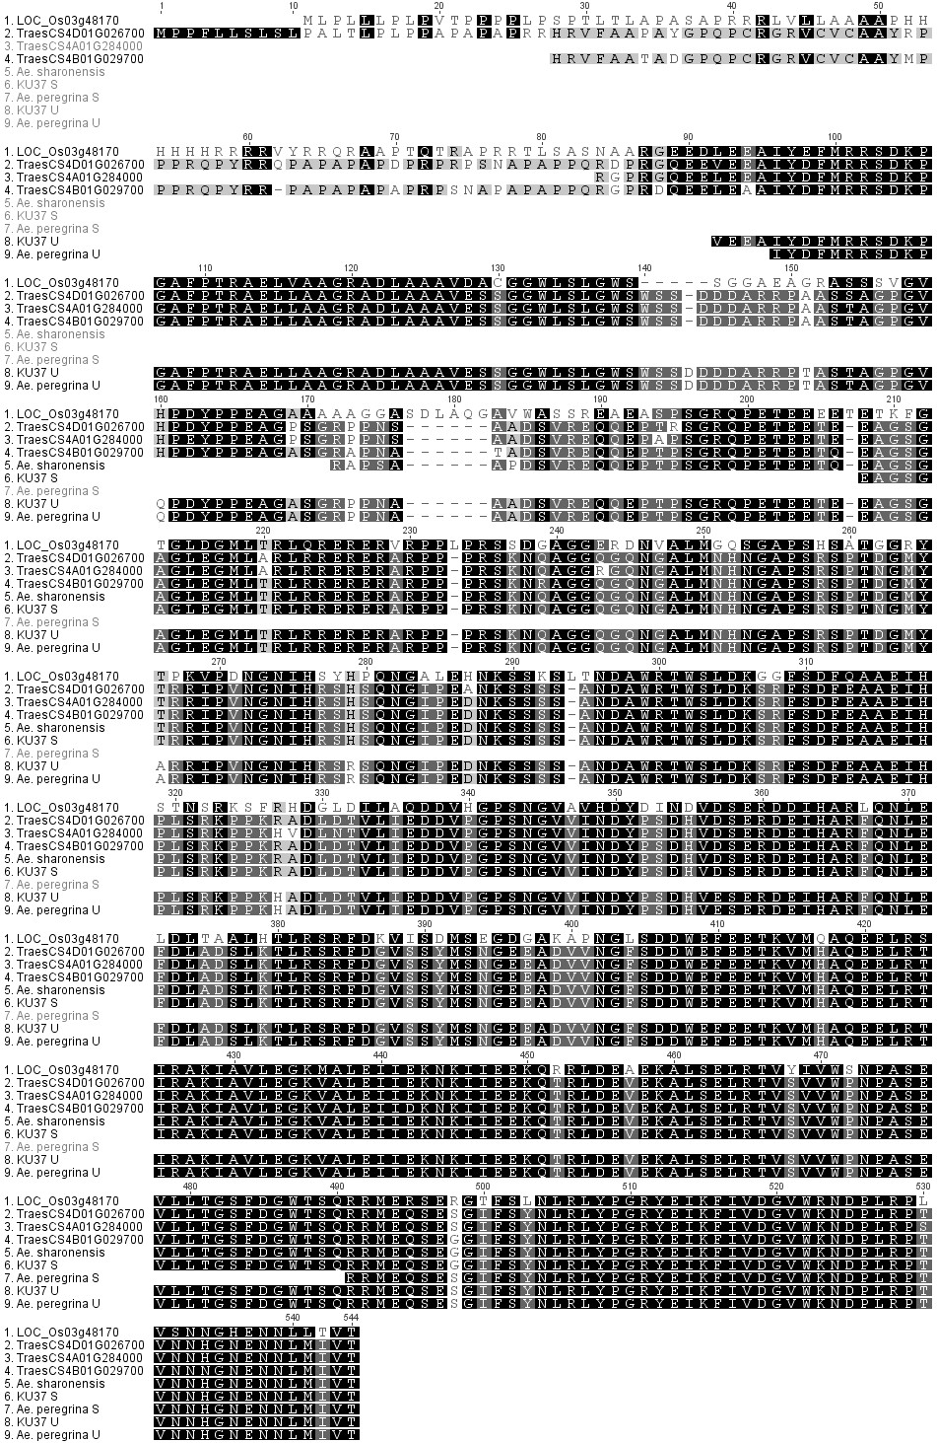
Supplementary Figure 2. Analysis of FLO6 genes in T. aestivum, Ae. peregrina and KU37.
A. PCR analysis of the FLO6 genes.
FLO6 fragments were amplified by PCR using genomic DNA from wheat (Chinese Spring, CS), KU37 (synthetic tetraploid Aegilops with B-type granules, KU) and Ae. peregrina (natural mutant lacking B-type granules, AP). The primers were designed to amplify regions (PCR products P1-P7) of either FLO6-U (upper panel) or FLO6-S (lower panel) as indicated in B. Molecular weight markers are loaded at either side of each gel with sizes as indicated.
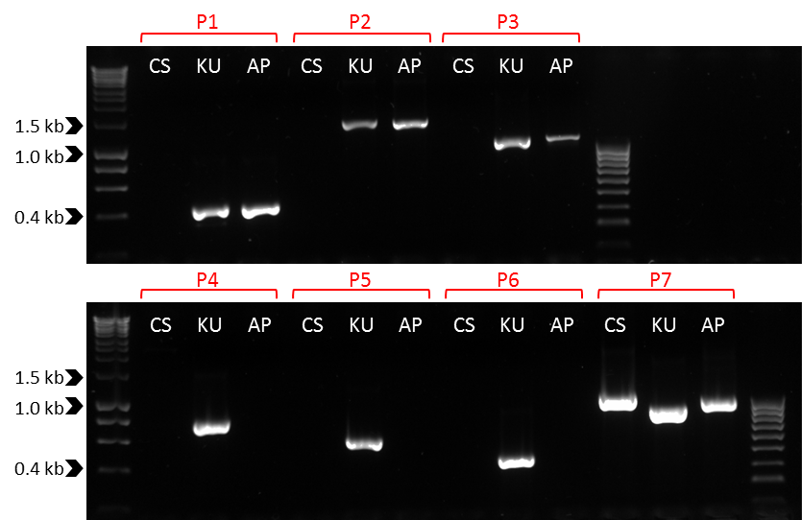
B. The positions of the PCR products in the FLO6 genes.
The gene structure is as in Figure 4. P1-P7 are the PCR products shown in A.
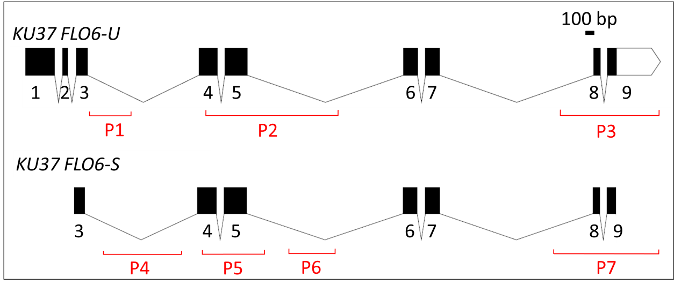

Supplementary Figure 3. The wheat FLO6 TILLING mutants.
- The positions of mutations in Kronos and Cadenza FLO6 genes (B) are indicated on the FLO6-A (TraesCS4A02G284000) and FLO6-B (TraesCS4B02G029700) gene structures. The effects of the mutations on the encoded proteins are indicated. 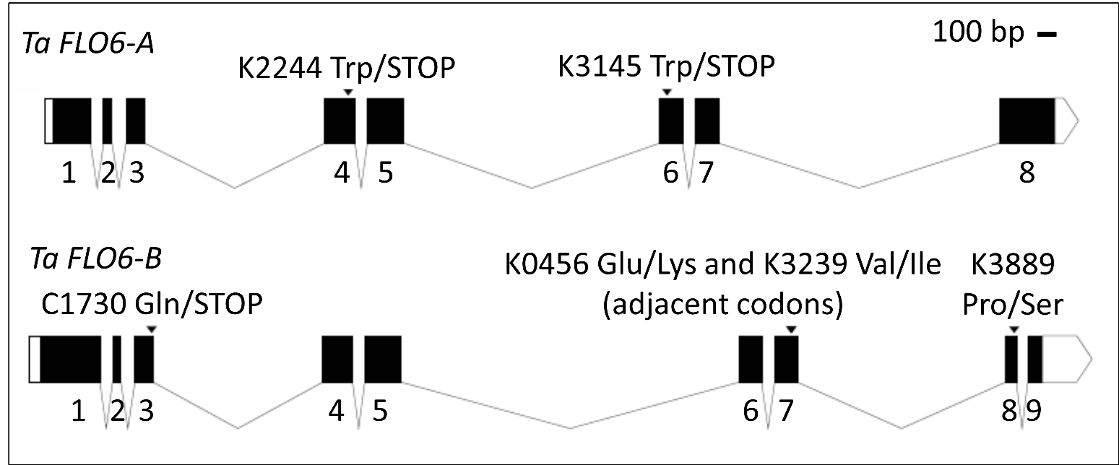
- Genotyping primers.
Cultivar (genome) | Chr | Mutant ID | Change to gene | Change to protein | Effect | Primer (VIC) | Primer (FAM) | Primer common
Kronos (AABB) | A | K2244 | G/A | Trp - STOP | nonsense | TTGTCAAGAGACCATGTTCGc | TTGTCAAGAGACCATGTTCGt | CTCCTAGTCGAAGTCCAACTA
Kronos (AABB) | A | K3145 | G/A | Trp - STOP | nonsense | TACTTTTGTCTCTTCAAATTCCc | ATTACTTTTGTCTCTTCAAATTCCt | GAAGATCTTGATGCATCTCATC
Kronos (AABB) | B | K0456 | G/A | Glu - Lys | missense | TATGGCCCAATCCTGCTTCAg | TATGGCCCAATCCTGCTTCAa | GCCACCCATTTTGTAGTTAGTTAG
Kronos (AABB) | B | K3239 | G/A | Val - Ile | missense | GCCCAATCCTGCTTCAGAAg | GCCCAATCCTGCTTCAGAAa | GCCACCCATTTTGTAGTTAGTTAG
Kronos (AABB) | B | K3889 | C/T | Pro - Ser | missense | CGCCATTACCTCATATCTACCAGg | CGCCATTACCTCATATCTACCAGa | ATAATCAAACACTGGACTTTTTCCT
Cadenza (AABBDD) | B | C1730 | C/T | Gln - STOP | nonsense | CGAGCGGGAGGGCAAGGTc | CGAGCGGGAGGGCAAGGTt | GCCGAGAGTTGAAAATGCACG

